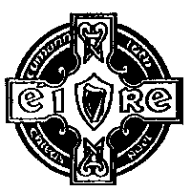 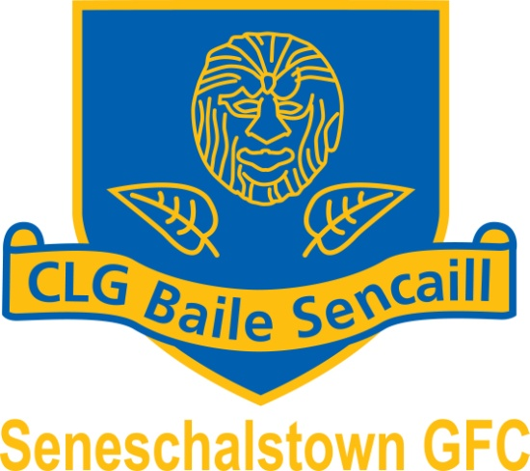 

(<http://www.seneschalstowngaa.com/>)

Chairperson: Secretary : Treasurer :

Kieran Mulvany Declan Kinsella Patrick Clarke

087 – 2388722 087-9392755 086 - 3858124

**Annual General Meeting**

A Chara Club Member

You are cordially invited to attend the Annual General Meeting of Seneschalstown GAA Club on **Thursday 9th January 2025 *at* 8pm** which will take place in Seneschalstown Clubhouse.

Please find enclosed a copy of our nomination and motions form.

Please note that our Mass for deceased members will be held in **Yellow Furze *Church*** on ***Sunday 5th January 2025 @ 11.00am.***

Is mise le meas

Deaglan Cinsealach

Runai

Baile Sencaill

  

(<http://www.seneschalstowngaa.com/>)

Chairperson: Secretary : Treasurer :

Kieran Mulvany Declan Kinsella Patrick Clarke

087 – 2388722 087-9392755 086 - 3858124

**Annual General Meeting Thursday 9th January 2025**

**Nomination Form**

*To be returned to Club Secretary(Declan Kinsella, Veldonstown, Brownstown, Navan Co Meath Email: Secretary.Seneschalstown.Meath@gaa.ie) Mobile: 0879392755****.***

***Note:*** *The consent of the person being nominate* ***must*** *be obtained. Members may be nominated for more than one position*

|  |  |  |
| --- | --- | --- |
| **Position** | **Outgoing** | **Nominations** |
| ***Presidents*** | *Fr Peter Farrelly, Ollie Geraghty, Thomas Mulvany, Tommy Collins, Sean Monaghan, Tommy Finnegan, Johnny McGovern, Fr David Brennan* |  |
| ***Chairperson #*** | Kieran Mulvany* |  |
| ***Vice – Chairperson#*** | Tony McDonnell* |  |
| ***Secretary#*** | Declan Kinsella |  |
| ***Assistant Secretary*** |  |  |
| ***Treasurer #*** | Pat Clarke |  |
| ***Assistant Treasurer*** | John Battersby |  |
| ***PRO#*** | Shane Mulvany |  |
| ***Safety Officer*** | John Battersby |  |
| ***Coaching Officer #*** | Eoin Finnegan |  |
| ***Club Football Pathway Manager*** | Ian Maguire |  |
| ***Irish Language Officer #*** | Ian Maguire |  |
| ***Children’s Officer #*** | Steven Dillon |  |
| ***Insurance Officer/Registrar #*** |  |  |
| ***Health and Wellbeing*** | Paul O’Brien |  |
| ***Co. Board Delegate*** | Declan Kinsella, John Battersby, Kieran Mulvany |  |
| ***Executive Committee#*** | David Gordon, Gerry McDonnell, Leo Sheridan, Michael Dillon, Roisin Commons, John Battersby, James Meade, Declan Byrne *, Seamus Lyons, Tracey Finnegan and Audrey Norris |  |

*# Automatic Members of Executive, along with 2 Player Rep and 5 Full members*

*\* Not seeking re-election for that position*

Signature: ________________________ Date: __________________

  

(<http://www.seneschalstowngaa.com/>)

Chairperson: Secretary : Treasurer :

Kieran Mulvany Declan Kinsella Patrick Clarke

087 – 2388722 087-9392755 086 - 3858124

**Annual General Meeting Thursday 9th January 2025**

**Motions**

*To be returned to Club Secretary(Declan Kinsella, Veldonstown, Brownstown, Navan Co Meath Email: Secretary.Seneschalstown.Meath@gaa.ie) Mobile: 0879392755.*

Motion 1: ________________________________________________________________________

________________________________________________________________________

________________________________________________________________________

________________________________________________________________________________________________________________________________________________________________________________________________________________________________________________________________________________________________

Motion 2:

________________________________________________________________________________________________________________________________________________________________________________________________________________________________________________________________________________________________________________________________________________________________________________________________________________________________________________________________________________________________________________________

Signature: ________________________

Date: __________________

…………………………….

Elizabeth Sheridan (Ass. Sec.)

Bellview, Dollardstown, Beauparc

Navan